**The Recovery of Mono Lake**

Assessing the effects of fresh water diversion by the Los Angeles Department of Water and Power,

Mono Lake, California (1850-2017)

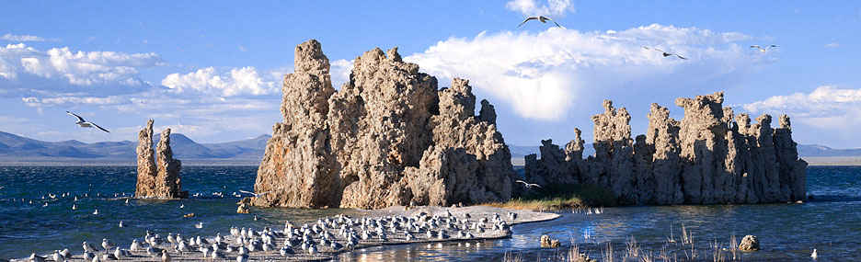

Tufa towers and California gulls on the shores of Mono Lake, CA. Image from: California Department of Parks and Recreation

**Prepared by Garrett M. Goto and Brad C. Anderson**

For ESM 206, Statistics & Data Analysis for Environmental Science & Management

Bren School of Environmental Science & Management

University of California, Santa Barbara

26 November 2017

**Introduction**

Mono Lake is a briny lake located in the Mono Basin, east of Yosemite National Park, sitting at the base of the leeward side of the Sierra Nevada range in California. The surrounding basin is geologically young (one to three million years old) due to its volcanic origin with the Mono Craters forming as recently as 40,000 to 700 years ago (Quick Facts, 2017). The lake is fed by snow melt from the nearby Sierra Nevada mountains, however with annual precipitation averaging 5 inches per year and evaporation rates of approximately 45 inches per year (Quick Facts, 2017), the salinity of Mono Lake can reach twice that of the ocean. Although there are no fish inhabiting the lake, it is home to extremely large populations of brine shrimp (*Artemia monica*) and alkali flies (*Ephydra hians*), of which are a sustaining food sources for millions of migratory birds (Quick Facts, 2017).

In 1941, the Los Angeles Department of Water and Power (LADWP) starting diverting the tributary streams surrounding Mono Lake to feed the growing municipal demand of Los Angeles. The 350-mile-long diversion of fresh water caused Mono Lake water levels to plummet (Figure 1) and salinity to double (The Mono Lake Story, 2017). In the rapidly changing environment, Mono Lake’s ecology was unable to adapt and the ecosystem began to deteriorate. This story was played out before at Owens Lake 100 miles to the southwest. LADWP began diverting water away from Owens Lake in 1913 and it was completely dry by 1926 ­—resulting in the single largest source of dust pollution in the United States (Reheis 1997).

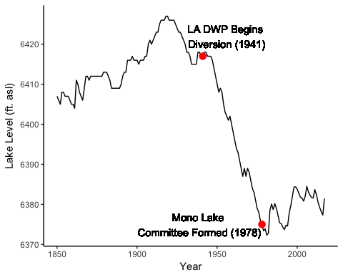

**Figure 1. Water levels in feet above sea level (ft. asl) at Mono Lake, CA from 1850 to 2017.** Los Angeles Department of Water and Power (LA DWP) begins diverting fresh water from tributaries in 1941 and the Mono Lake Committee was formed in 1978 to protect Mono Lake water resources. Data source: 1850-1912 from Stine, Scott (based on occasional observations and San Francisco precipitation). 1912-1979 from LADWP and USGS compilations. 1979-present from Los Angeles Aqueduct Daily Reports, and observations by the Mono Lake Committee. Compiled by the Mono Lake Committee.

David Gaines formed the Mono Lake Committee in 1978 in order to address the impacts that the LADWP had on the lake and prevent it from reaching total collapse. The Mono Lake Committee was able to file a Public Trust Suit (1979) charging the LADWP with violating the Public Trust Doctrine (Political & Legal Chronology, 2017). However, it was not until September 28, 1994 when the State Water Resources Control Board issued an amendment to LADWP’s diversion license which required that the lake reach a stable level of 6392 feet above sea level (ft. asl) (Political & Legal Chronology, 2017).

Understanding the implications of the fresh water diversion at Mono Lake is important for future management strategies of fresh water resources and migratory bird habitat. This report looks into how close the lake was to irreversible alteration and how slowly a recovery to stable conditions is going to be.

**Data and Methods**

Two linear models were created (Figure 2 and 3) to explore how the lake levels in the years of unrestricted diversion compared to the years after the formation of the Mono Lake Committee, when diversion was restricted. The lake elevation data (feet above sea level) were collected from several sources: the 1850-1912 data are from occasional observations by Scott Stine and from San Francisco precipitation measurements; the 1912-1979 data are from LADWP and USGS compilations; and the 1979-present data are from Los Angeles Aqueduct Daily Reports and observations by the Mono Lake Committee. In total this accounts for 168 years of lake level data. The critical salinity of 150 grams/liter at a lake level of 6,350 feet was determined by the National Research Council and Mono Basin Ecosystem Study Committee. The stable lake level of 6,392 feet was established by the California State Water Resources Control Board.

To predict how long Mono Lake could have supported the bird population if LADWP had continued unrestricted diversion, linear regression analysis by ordinary least squares was performed on the lake level data for the years 1941 to 1978. The Pearson product-moment correlation (Pearson's r) value was then calculated to determine if a correlation exists between the year and lake elevation during LADWP diversions (Figure 2). This same process was applied to the lake elevation data following the creation of the Mono Lake Committee, 1978 to present (Figure 3).

Nest count data for the California gull (*Larus californicus*) was examined for the years 1990, 2000, and 2010 to explore how changing lake elevations affect where the gulls locate their nests. This data is collected annually in May by field workers that survey Mono Lake gull colonies and it is published in the report, "Population size and reproductive success of California Gulls at Mono Lake, California." Using this data (Table 1) we compare the gull nest counts for three small islets near Negit Island, ranging in size from 0.3 to 5.3ha (Wrege et al. 2006): Twain, Little Tahiti, and Pancake (Figure 4), for the years 1990, 2000, and 2010. A chi-square test of goodness-of-fit was performed on the bird counts to decide if there is an association between the year and the nesting location.

All data analysis and graphical displays were conducted in RStudio statistical software (v. 1.0.136).

**Results and Discussion**

Unrestricted Diversion by LADWP (1941-1978)

Lake elevation is significantly predicted by year from 1941 to 1978, (b = -1.2215, t(36) = -52.53, p < 0.001) with a strong negative correlation between year and lake elevation (ft. asl) (Pearson's r = -0.99). The overall model explains a significant amount of variance in lake elevation (ft. asl)(F(1,36) = 2760, p < 0.001, R2 = 0.9868). The average rate of decrease in lake elevation (1941 to 1978) is -1.22 feet per year.

Given these results, our linear model predicts that if the trend of water diversion continued, the lake would reach the critical salinity level of 150 g/l at a lake elevation of 6,350 feet early into the year 1999. Currently, Mono Lake at its deepest is 157 feet, with an average depth of 56 feet. If diversions had continued unabated the lake would be totally dry by 2019.

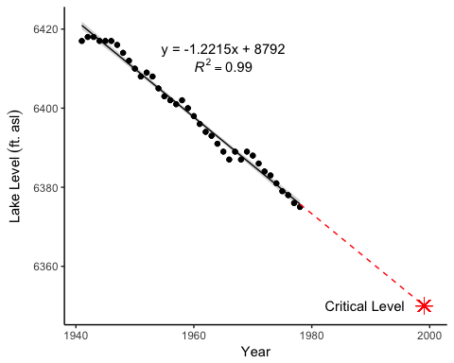

**Figure 2. Mono Lake water levels during the LA DWP diversion period.** Lake levels (feet above sea level) is significantly predicted by the year (1941 to 1979, n = 38) during the LA DWP water diversion (F(1,36) = 2760, *p* < 0.001, R2 = 0.9868). Gray ribbon indicates 95% confidence interval, red dashed line shows extrapolated water diversion rate, and star indicates the critical level at which acute salinities would be above 150 g/L (6350 ft. asl). Data Source: 1850-1912 from Stine, Scott (based on occasional observations and San Francisco precipitation). 1912-1979 from LADWP and USGS compilations. Compiled by the Mono Lake Committee.

Mono Lake Committee (1979-2017)

Lake level is significantly predicted by year from 1979 to 2017, (b = 0.1979, t(37) = 4.72, p < 0.001) with a moderately positive correlation between year and lake elevation (ft. asl) (Pearson's r = 0.61). The overall model explains a significant amount of variance in lake level (ft. asl) (F(1,37) = 22.28, p < 0.001, , R2 = 0.3589). The average rate of increase in lake level (1979 to 2017) is 0.1979 feet per year.

Our linear model predicts that with water restrictions in place after the formation of the Mono Lake Committee, the lake would reach the stable level of 6,392 feet in 2062. Furthermore, at current refill rates it will take until 2190 to restore the lake to its natural, pre-diversion elevation of 6,417 feet.

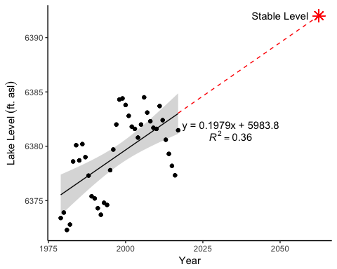

**Figure 3. Mono Lake water levels after the establishment of the Mono Lake Committee.** Lake levels (feet above sea level) is significantly predicted by year (1979 to 2017, n = 39) after the Mono Lake Committee was formed (F(1,37) = 22.28, *p* < 0.001, R2 = 0.3589). Gray ribbon indicates 95% confidence interval, red dashed line shows extrapolated water recovery rate, and star indicates the stable level as dictated by the California State Water Resources Control Board. Data Source: 1979-present from Los Angeles Aqueduct Daily Reports, and observations by the Mono Lake Committee. Compiled by the Mono Lake Committee.

Gull Nests on the Negit Islets

For the Negit Island islets of Twain, Little Tahiti, and Pancake, there is a significant association between year and nesting location for gulls from 1990 to 2010 (2 (4, n = 51,196) = 2075.7, p < 0.001). Examination of standardized residuals revealed that all locations contributed to the non-independence of the data. However, the most significant contributions were seen on Pancake Island from 1990 to 2010 and Twain Island from 1990 to 2010.

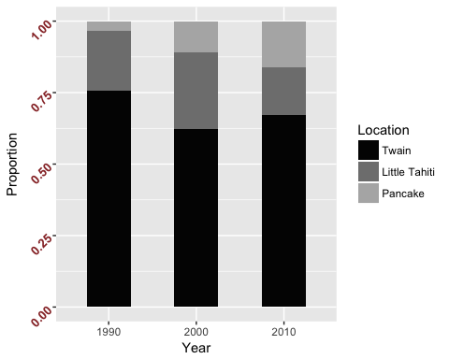

**Figure 4. California gull nests (as a proportion during 1990, 2000, and 2010) at three islet locations (Twain, Little Tahiti, and Pancake) on Negit Island, Mono Lake, CA.** There is a significant association between gull nest counts and year observed (2 (4, n=51, 196) = 2075.7, *p* < 0.001). Data source: Nelson, Kristie N., and Ann Greiner. "Population size and reproductive success of California Gulls at Mono Lake, California." (2016).

Twain Islet has the largest proportion of California gull nests throughout the three years sampled (76%, 62%, and 67% for 1990, 2000, and 2010 respectively). Although the proportions of nests at Pancake Islet were consistently the smallest of the three locations (3%, 11%, and 16% for 1990, 2000, and 2010 respectively), the proportions are increasing over time. It is also worth noting that the total gull nest counts (Table 1) have been decreasing from 1990 to 2010.

**Table 1. Gull nest counts for Negit Islets Twain, Little Tahiti, and Pancake.** Gull nests for each site location per year along with total nest counts per year. Percentages are a proportion of gull nests at an individual site over total gull nests accounted for in that year. Data source: Nelson, Kristie N., and Ann Greiner. "Population size and reproductive success of California Gulls at Mono Lake, California." (2016).

|  |  |  |  |
| --- | --- | --- | --- |
|  | **1990** | **2000** | **2010** |
| **Twain** | 15045 (75.5%) | 11856 (62.3%) | 8219 (67.1%) |
| **Little Tahiti** | 4218 (21.2%) | 5076 (26.7%) | 2049 (16.7%) |
| **Pancake** | 651 (3.3%) | 2098 (11%) | 1984 (16.2%) |
| **Total** | 19914 | 19030 | 12252 |

Although the reason for the decrease in California gull population at Mono Lake is unconfirmed, there are contributing factors such as predation, change in brine shrimp densities, temporal variation, and recruitment that are all likely factors (Nelson, 2016).

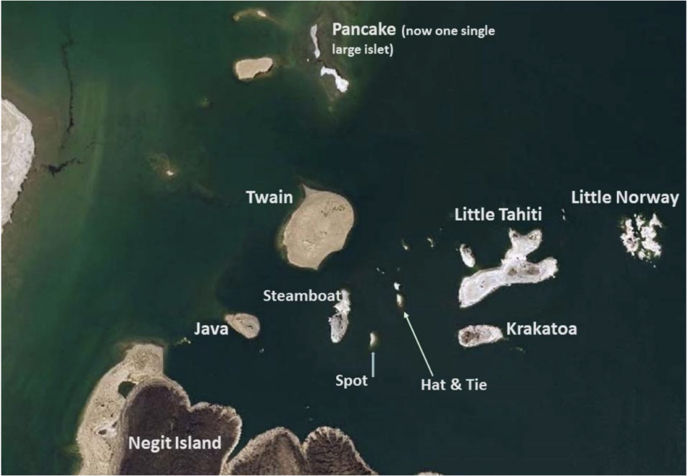

**Figure 5. Map of the Negit Island islets at Mono Lake, CA.** Surface level of lake is >1m above the 2016 breeding season level (Nelson, 2016). Image from: Nelson, Kristie N., and Ann Greiner. "Population size and reproductive success of California Gulls at Mono Lake, California." (2016).

As lake levels change to open land bridges for predators, locations of gull nests likely indicate movement to more difficult to access islets. Figure 5 shows the distribution of the Negit Islets in 2016 when the lake level was at 6377 ft. asl.

**Conclusion**

The freshwater diversion by the LADWP and the resulting counter-action by the Mono Lake Committee has had marked effects on the physical and ecological characteristics at Mono Lake. Our report has three major findings:

1. There is a clear and significant trend of decreasing water levels while the LADWP was diverting water towards the city of Los Angeles. Had it continued, water levels would have hit critical salinity levels in 1999 and the lake would have been completely dry by 2019.
2. Since the formation of the Mono Lake Committee, lake water levels are on the rise. However, with seasonal variability and the effects of climate change, the estimated year of reaching stable levels of 2062 is more unpredictable.
3. Lower water levels have opened access to coyotes, which can predate gull eggs and juveniles on the lake’s islets. This pressure has lead to a movement of gull nests to harder to access islets, but has ultimately contributed to a decrease in nests.

There are several limitations to this study. When looking at lake levels, seasonal variability such as precipitation, is not taken into account. This is especially important in estimating when the lake will reach stable levels, as the amount of precipitation and snow melt is necessary to increase the lake water levels. Looking at more gull nest locations and counts, as well as more years, would help to make a clearer conclusion about how gull nests are changing over time.

Future studies need to continue to collect and analyze lake level data to get a more accurate estimate of when the lake will reach stable levels. Predator prevention techniques should be implemented and studied to see the effects of coyote predation on gull nests. The Mono Lake Committee also notes: “If enough coyotes learn to wade or swim to nearby islets, they would be rewarded with helpless eggs or chicks, disrupting nesting birds on Negit or any other islet” (The Mono Lake Story, 2017).

**References**

California State Parks, State of California. “Mono Lake Tufa SNR Image Gallery*.*”

<https://www.parks.ca.gov/ImageGallery/?page_id=514>. Accessed November 22, 2017.

Mono Basin Clearing House. “Political & Legal Chronology*.*”

<http://www.monobasinresearch.org/timelines/polchr.php>. Accessed November 22, 2017.

Mono Lake Committee. “The Mono Lake Story.” 2017. <http://www.monolake.org/about/story>. Accessed

November 24, 2017.

Mono Lake Committee. “Quick Facts*.*” 2017. <http://www.monolake.org/about/stats>. Accessed November

23, 2017.

National Research Council, and Mono Basin Ecosystem Study Committee. “The Mono Basin ecosystem:

effects of changing lake level.” National Academies Press, 1987.

Nelson, Kristie N., and Ann Greiner. "Population size and reproductive success of California Gulls at

Mono Lake, California." (2016). <http://www.monobasinresearch.org/images/gulls/2016.pdf>.

Reheis, Marith C. "Owens (dry) Lake, California: A human-induced dust problem." (1997).

Wrege, Peter H., Justin M. Hite, Tricia Wilson, and Joel Ellis. "Population size and reproductive success

of California Gulls at Mono Lake, California, in 2001, with emphasis on the Negit Islets." (2001).

<http://www.monobasinresearch.org/images/gulls/2001.pdf>.